
Lab Performance: 02 (SRS, Use Case Diagram,Activity Diagram,ER Diagram)
Project Title : FarmFusion - Smart Agro-Diary Eco System

Only for course Teacher
 |  | Needs Improvement | Developing | Sufficient | Above Average | Total Mark
Allocate mark & Percentage |  | 25% | 50% | 75% | 100% | 15
Clarity | 3
Content Quality | 6
Spelling & Grammar | 3
Organization and Formatting | 3
Total obtained mark
Comments

Semester: Spring 2026 Group: 04

Name | ID | Batch | Section
Md Sakib Hossain | 242-35-239 | 43 | F1
Md Bayezid Mukabbir | 242-35-041 | 43 | F1
Sheikh Saymon Mahmud | 242-35-477 | 43 | F1
Md Jahid Haider Helale | 242-35-084 | 43 | F1

Course Code: SE231
Course Name: System Analysis & Design Capstone Project
Course Teacher Name: Md. Selim Reza
Designation: Assistant Professor Submission Date: 13/07/2026

Software Requirements Specification (SRS)
Project Title: FarmFusion – Smart Agro-Diary Ecosystem

1. Introduction

1.1 Purpose
This Software Requirements Specification (SRS) document describes the functional and non-functional requirements of the FarmFusion system. FarmFusion is a mobile application-based Smart Agro-Diary Ecosystem designed to modernize cow farm management for smallholder dairy farmers in Bangladesh. This document provides a comprehensive specification of system features, behaviors, and constraints to guide the development team and serve as a reference for stakeholders.

1.2 Scope
FarmFusion provides a fully integrated Android mobile application for cow farm management, covering cow records digitization, milk production tracking, health and vaccination management, feed management, financial oversight, dairy product management, waste management and AI-powered features for predictive insights, automation, and smart decision support. The system supports four user roles: Farm Owner, Farm Worker, Veterinary Advisor and Customer, each with role-based access to relevant modules. The application is built using Java for Android with Firebase cloud backend and SQLite for offline support.

2. Overall Description

2.1 Product Perspective
FarmFusion is a mobile-first platform supported by Firebase cloud services for online synchronization and SQLite local storage for offline functionality. It integrates cow management, health monitoring, financial tracking, and dairy product management into a single unified Android application. Unlike existing platforms such as Smart Dairy BD, Mimba, and Digital Khamari – which address only partial aspects of dairy farming – FarmFusion brings all farm operations into one comprehensive mobile application.

2.2 User Classes
Farm Owner:
Primary user with full access to all modules. Manages cows, monitors milk production, oversees financials, and reviews reports.
Farm Worker:
Day-to-day operational user who records milk yield, updates feed logs, and manages health entries under supervision of the farm owner.
Veterinary Advisor:
Specialist user who accesses cow health records, updates vaccination schedules, and provides treatment recommendations.
Customer:
Buys dairy products via the app — browses listings, places orders, tracks status, and pays online. No access to farm management or financial modules.

2.3 Operating Environment
- Mobile App: Android (Java-based, compatible with Android 6.0 and above)
- Backend: Firebase (Authentication, Realtime Database, Cloud Firestore)
- Local Database: SQLite (for offline support in rural areas)
- IDE: Android Studio
- Version Control: GitHub

3. System Requirements

Software Requirements:
- Operating System: Android 6.0 (Marshmallow) and above
- Programming Language: Java
- IDE: Android Studio
- Backend: Firebase (Authentication, Realtime Database, Cloud Firestore)
- Local Database: SQLite
- UI: XML Layouts with Material Design Components
- Version Control: GitHub
- API Testing: Postman
- AI/ML layer for predictive insights and automation

Hardware Requirements:
- Android smartphone (low-end and mid-range devices for rural compatibility)
- Smartphone camera (for cow identification and health documentation)
- Internet connectivity (optional – app functions offline via SQLite)
- Development laptops/PCs with Android Studio
- Cloud server (Firebase infrastructure)

4. Functional Requirements

FR1: User Registration
Description | System shall allow Farm Owners, Farm Workers, Veterinary Advisors and Customer to register using name, mobile number, role, and farm location.
Stakeholders | Farm Owner, Farm Worker, Veterinary Advisor, Customer

FR2: Secure Login
Description | System shall authenticate users using secure login with credentials. Role-based redirection to the appropriate dashboard shall occur upon successful login.
Stakeholders | Farm Owner, Farm Worker, Veterinary Advisor,Customer

FR3: Password Recovery
Description | System shall allow users to reset their password through a verification process via registered mobile number.
Stakeholders | Farm Owner, Farm Worker, Veterinary Advisor,Customer

FR4: Role-Based Access Control
Description | System shall provide role-specific access where Farm Owner has full access, Farm Worker has operational access, Veterinary Advisor has health module access, and Customer has access limited to dairy product browsing and ordering.
Stakeholders | Farm Owner, Farm Worker, Veterinary Advisor,Customer

FR5: Profile Management
Description | Users shall be able to update their profile data, farm location, and personal information.
Stakeholders | Farm Owner, Farm Worker

FR6 : Cow Profile Creation
Description | System shall allow Farm Owners and Workers to create individual digital profiles for each cow, including breed, age, weight, identification tag, and ownership history. And also AI can breed/weight from photo (image recognition), automatic tagging
Stakeholders | Farm Worker

FR7: Search & Filter Cow Records
Description | System shall allow users to search and filter cow records by criteria such as ID tag, breed, age, weight, or ownership status, enabling quick retrieval of specific cow profiles.
Stakeholders | Farm Owner, Farm Worker, Veterinary Advisor

FR8: Image Upload
Description | System shall allow users to upload images from device storage
Stakeholders | Farm Owner, Farm Worker, Veterinary Advisor

FR9: Cow Life Cycle Dashboard
Description | System shall provide a visual dashboard displaying the complete life cycle of each cow, including birth, growth stages, milk production, health records, breeding, and aging, in a timeline-based and interactive format.
Stakeholders | Farm Owner, Farm Worker, Veterinary Advisor

FR10: Smart Alerts & Notifications
Description | System shall provide AI-driven smart alerts and notifications by continuously analyzing cow data such as milk production, health records, feeding patterns, and vaccination schedules. The system will detect anomalies, predict potential risks, and generate prioritized alerts (e.g., sudden drop in milk yield, possible illness, missed vaccination, or abnormal behavior) to support timely decision-making
Stakeholders | Farm Owner, Farm Worker, Veterinary Advisor

FR11: Daily Milk Yield Recording
Description | System shall allow Farm Workers to record daily milk yield per cow with date and time stamps.
Stakeholders | Farm Owner, Farm Worker

FR12: Milk Production Analytics & Reporting
Description | System shall use AI to analyze historical milk production data, identify patterns, detect anomalies, and generate automated reports with predictive insights, including daily, weekly, and monthly summaries.
Stakeholders | Farm Owner

FR13 : Health Record Management
Description | System shall store and manage individual cow health records including illness history, treatment logs, and recovery status.
Stakeholders | Farm Owner, Veterinary Advisor

FR14: Vaccination Scheduling
Description | System shall allow Veterinary Advisors to set vaccination schedules for individual cows or the entire herd.
Stakeholders | Veterinary Advisor, Farm Owner

FR15: Automated Health Alerts
Description | System shall use AI to analyze health records and schedules to predict and notify Farm Owners and Workers about upcoming or high-priority vaccinations, checkups, and treatments with smart prioritization and risk-based alerts.
Stakeholders | Farm Owner, Farm Worker, Veterinary Advisor

FR16 :Smart Feed Management System
Description | System shall manage feed inventory by tracking stock levels and generating low-stock alerts, while using AI to optimize and dynamically adjust feeding schedules based on cow health, age, milk production, and available feed resources..
Stakeholders | Farm Owner, Farm Worker

FR17 : Nutritional Optimization
Description | System shall use AI to recommend optimal feed quantities for each cow based on milk yield targets and health data.
Stakeholders | Farm Owner, Veterinary Advisor

FR18 :Financial Management & Analytics
Description | System shall allow Farm Owners to record all farm income (milk sales, product sales) and expenses (feed, medicine, labor costs).use AI to generate financial reports with profit/loss analysis, trend insights, and predictive forecasts.
Stakeholders | Farm Owner

FR19 : Dairy Product Management
Description | System shall track the production, inventory, and sales of milk-derived products including ghee, yogurt, and cheese.
Stakeholders | Farm Owner, Farm Worker

FR20: Product Browsing (Dairy Product Menu)
Description | System shall display all available dairy products (milk, ghee, yogurt, cheese) with images, price, and stock using an organized interface.
Stakeholders | Farm Owner, Farm Worker, Customer

FR21 : Product Recommendation
Description | System shall use AI to recommend products based on customer preferences, past purchases, and popular items
Stakeholders | Farm Owner, Farm Worker, Customer

FR22: Product Search & Filter
Description | System shall allow customers to search and filter products by category, price, or availability.
Stakeholders | Farm Owner, Customer

FR23 : Add to Cart
Description | System shall allow customers to add selected products to a shopping cart before purchase.
Stakeholders | Customer

FR24: Smart Checkout & Payment Processing
Description | System shall manage the complete checkout process including automatic total cost calculation (tax, discount, delivery charges), order confirmation, and payment handling, while using AI to provide personalized discounts and detect suspicious payment activities.
Stakeholders | Customer

FR25: Dairy Product Sales Record
Description | System shall record product sales transactions and update inventory automatically after each sale.
Stakeholders | Farm Owner, Farm Worker

FR26: Waste Recording
Description | System shall allow users to record daily cow waste production including quantity and type.
Stakeholders | Farm Owner, Farm Worker

FR27: Waste Utilization Tracking
Description | System shall track cow waste utilization including biogas generation and organic compost production.
Stakeholders | Farm Owner

FR28: Unified Farm Dashboard
Description | System shall use AI to provide real-time insights, alerts, and summarized farm performance data. And also display a unified dashboard showing real-time milk production trends, cow health status, feed inventory level, and financial summary.
Stakeholders | Farm Owner

FR29: Report & Analytics Module
Description | System shall provide interactive visual dashboards and downloadable reports for all farm operations, while using AI to analyze data, detect patterns, and generate actionable insights and predictions
Stakeholders | Farm Owner

FR30: Offline Functionality
Description | All core features of the application shall function without internet connectivity using SQLite local storage, with automatic data synchronization to Firebase when connectivity is restored.
Stakeholders | Farm Owner, Farm Worker, Veterinary Advisor

FR31: User Feedback
Description | System shall allow users to submit feedback, suggestions, and issue reports about application features.
Stakeholders | Farm Owner, Farm Worker, Veterinary Advisor

FR32: Bangla Text Response
Description | System shall use AI to generate and display advisory results in Bangla language for better user understanding.
Stakeholders | Farm Owner, Farm Worker, Veterinary Advisor,Customer

FR33: AI-based Bangla Voice Interaction
Description | System shall use AI-based speech recognition and text-to-speech technologies to enable complete Bangla voice interaction, allowing users to input queries through voice and receive advisory results in natural Bangla voice output.
Stakeholders | Farm Owner, Farm Worker, Veterinary Advisor,Customer

FR34: AI Farm Assistant
Description | System shall provide an AI-powered chatbot assistant that allows users to interact using text or voice, ask questions, and receive intelligent responses by utilizing all underlying AI modules such as health analysis, feed recommendation, and production insights.
Stakeholders | Farm Owner, Farm Worker, Veterinary Advisor

FR 35 : Logout
Description | System shall allow users to securely log out from their account, terminating the current session and preventing unauthorized access.
Stakeholders | Farm Owner, Farm Worker, Veterinary Advisor , Customer

5. Non-Functional Requirements

NFR1: Performance
Description | Application shall load the main dashboard within 3 seconds and all module transitions shall complete within 2 seconds under normal operating conditions.
Stakeholders | Farm Owner, Farm Worker, Veterinary Advisor, System, customer

NFR2: Usability
Description | User interface shall be simple, icon-based, and intuitive enough for users with low digital literacy to use the application without prior technical training.
Stakeholders | Farm Owner, Farm Worker, customer

s
NFR3 : Reliability
Description | System shall ensure data integrity during offline usage and guarantee no data loss during synchronization events.
Stakeholders | Farm Owner, Farm Worker, Veterinary Advisor, customer

NFR4: Security
Description | All user credentials and farm financial data shall be protected using Firebase Authentication. Sensitive data shall be encrypted both in transit and at rest.
Stakeholders | All Users

NFR5 : Accessibility
Description | Application shall support high-contrast display mode and large text options suitable for outdoor field use in various lighting conditions.
Stakeholders | Farm Owner, Farm Worker

NFR6: Maintainability
Description | Application codebase shall follow modular architecture principles, be well-documented, and version-controlled on GitHub to support future updates and maintenance.
Stakeholders | Development Team

NFR7 : Scalability
Description | System shall support individual smallholder farms as well as large commercial dairy operations with hundreds of cows and multiple farm workers.
Stakeholders | Farm Owner, System

NFR8: Portability
Description | Application shall run on Android devices with version 6.0 (Marshmallow) and above, including low-end devices commonly used in rural Bangladesh.
Stakeholders | Farm Owner, Farm Worker, customer

NFR9: Compatibility
Description | Application shall function under low-bandwidth and intermittent internet connectivity conditions, with SQLite ensuring full offline capability.
Stakeholders | Farm Owner, Farm Worker

NFR10: Data Integrity
Description | Offline data collected via SQLite shall synchronize completely and without loss to Firebase Cloud when internet connectivity is restored.
Stakeholders | Farm Owner, Farm Worker, System

NFR11: Localization
Description | System shall support Bengali (Bangla) language interface as the primary language option alongside English for rural farmers.
Stakeholders | Farm Owner, Farm Worker, customer

NFR12: Compliance
Description | System shall comply with applicable data privacy regulations and agricultural data management guidelines in Bangladesh.
Stakeholders | Farm Owner, System

Use Case Diagram

The Use Case Diagram below illustrates the interactions between the three primary user roles – Farm Owner, Farm Worker, and Veterinary Advisor – and the FarmFusion system. It shows all major use cases including user authentication, cow management, milk production tracking, health and vaccination management, feed management, financial tracking, dairy product management, waste management, and report generation.
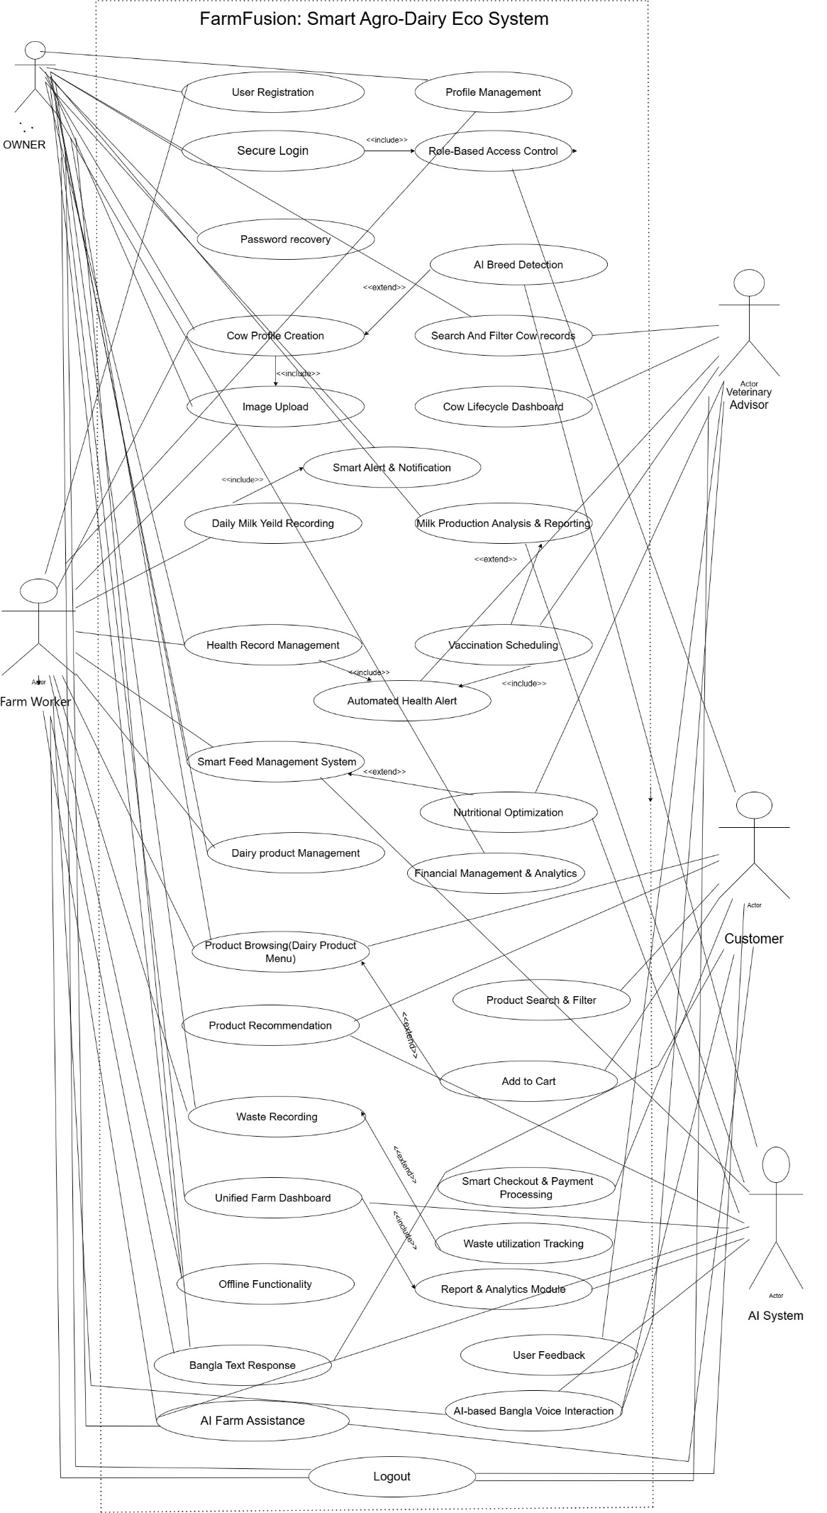
Activity Diagram

1.User Authentication (Login/Registration)

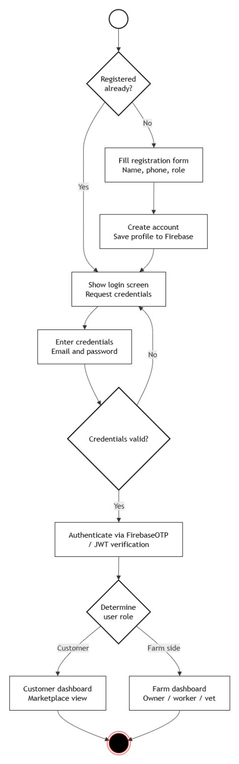

2. Milk Production & Analytics

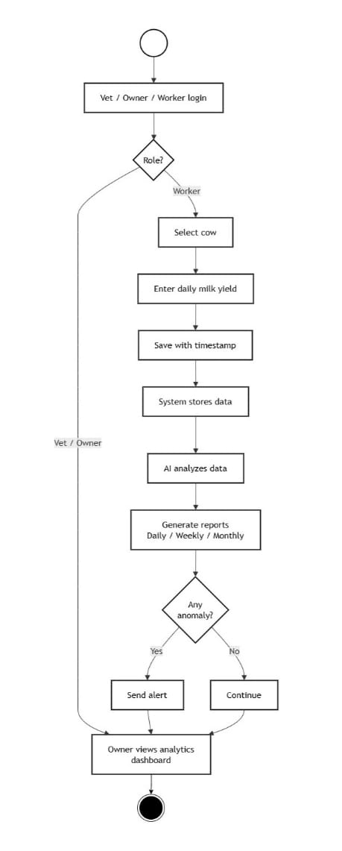

3 . Health & Vaccination Management
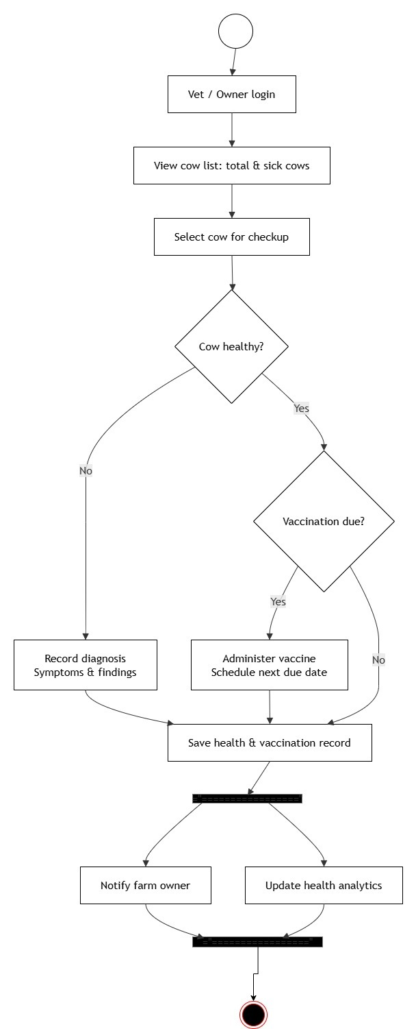

ER Daigram:

The ER Diagram illustrates the database structure of the FarmFusion system by showing the main entities, their attributes, and the relationships between them. It represents how data related to users, cows, milk production, health records, products, orders, and financial transactions are organized within the system. This diagram serves as the foundation for designing an efficient, consistent, and well-structured database that supports all core functionalities of the application.

